EUROPE DOMINATES IN

COCOA BEAN IMPORTS GLOBALLY

The continent boasts of a strong chocolate processing and manufacturing industry. Its cocoa bean imports increased by 25.2% from 2015 to 2019, 82% of which were sourced directly from producing countries in 2019.

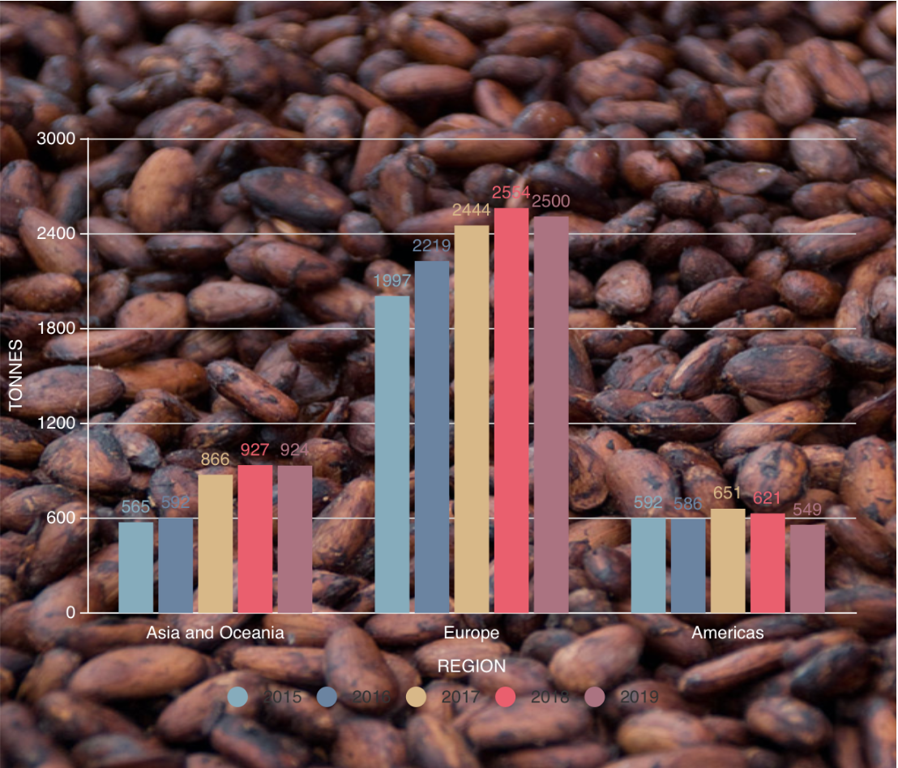

AUTHOR: Zoya Mirza SOURCE: CBI (Centre for the Promotion of Imports)